Gmail - LEE Family Tree Page 1 of 3
G Glenn Holliman< glennhistory@gmail.com>
tgg4:_{ti}ztzz_{is}
Anne Holmes < am.holmes@htinternet.com> Mon, Dec 17, 2012 at 4:56 PM
To: Glenn Holliman <glennhistory@gmail.com>
Dear Glenn
I hope you have arrived safely at your destination and I hope you enjoy your seasonal break
I have attached a basic family tree for the LEES of Hartwell for you. It dates from the mid C15 to the end of
the C18.
The LEE family originally settled in the small hamlet of Moreton, in the parish of Dinton, Buckinghamshire
possibly sometime in the fifteenth century. At that time the family were just landed gentry, see
http://www.british-history.ac.uk/report.aspx?compid=62771&strquery=Lee
/The Thomas LEE who died in 1572 (father in law of Christopher HOLYMAN) was still of that landed gentry
class. He does not describe himself as either Gentleman or Knight in his Will. However, his son Thomas,
who died in 1626 does describe himself as Knight in his Will. It was possibly the marriage ofThornas LEE
to Eleanor HAMPDEN that instigated the knighthood for Thomas. Eleanor HAMPDEN was the sister of Sir
Alexander HAMPDEN. It was after the death of Alexander HAMPDEN, in 1618, that Hartwell House T
passed to Thomas LEE through his wife Eleanor, see http://www.british-history.ac.uk/report.aspx?
compid=62775&strquery=Lee It may be at this point in time Thomas LEE acquired his knighthood: it
perhaps came with the Hartwell Estate. By the end of the seventeenth century the LEES have become
Baronets. In contrast, the HOLYMAN family star in Buckinghamshire is at its brightest in the mid sixteenth
century when Thomas HOLYMAN held the manor of Cuddington and his kinsman John HOLYMAN was
Bishop of Bristol. In the mid sixteenth century the HOLYMAN and LEE families would probably have been
seen as contemporary equals in social status hence the marriage of Christopher HOLYMAN to Margaret
LEE
The sources I used to compile the tree are as follows:
Will of John HOLYMAN of London 1578
Will of Christopher HOLYMAN of Sherington 1588
Will of Thomas LEE of Dinton 1572
Will of Sir Thomas LEE 1626
Will of Dame Eleanor LEE 1633
https://mail.google.com/mail/u/0/?ui=2&ik=9e29275475&view-⁻⁻-pt&search=inbox&th=1... 12/18/2012

130. LEE, of HARTWELL, Buckinghamshire_

Cirmied Barone. Aur.ust i6, Wig%
TIIIS family bad flourished ^{ping} this county previou3 to their advancement to
Baronet, ;I a Relti•alc.Tica1 account driwri up by Brow RI! Willis,
7;rateti that they ;are a branch i.egia, and Lvint.,:,⁻1 .:;:her
re ; -and that their immediate ancestor, retiring out the way .4:1 tht• persecution
tl:at family tinderwrut for taking part with Ric. 1E. agaitv4 his; umirping
-ceor,, st•tirril t•⁻; Buckinghamshire, early g Henry the Fonrth's reign.
Ileir seat was at .7‘.1( .r :.1: the parish I ⁾;.11i-⁻., adjoining to Hartwell ;
one fk; The OltiCSt alpIVITIentS I l‘r..*.:t₄ ebitrdl iS iilal_iank Lev, Esq. and
1.,%ifr, which ‘Vahri^{m}inlereased 9th ile^{i}tolpyr
l'hcy pfyscss ilartweli. by d escent, through the families Iinrnpticn, Sinf4e-
1, Ste LA,..".„ and Luton, front dire, dituttlIter and heiress if Winiam
217,,Intl.stm to IttroalLE., If; ritv,ell, TI) whorn this minor Lad
,n granted by the crown, :!! the 1 .L11 century.
They residrd for fivc zuneratiuni and upivitards at ‘.21,* _{-its'} , %%hew thr T⁴11'1,15
**/E Nom-
sirsept, surrmia14 a_aw_Lut.. s⁻ill visible.
died .-. October T4S6, left i5sue
wily, a son aid he :r.
2„ t,, who died
ice; a wal,_{if}t.
r,.;„ FrmicisFv‘ho was father
`J-c;mas Lt.c. ⁴•' ..!‘ ;Ind 11,0 E3ct CIZIViit111₇ COUilty_{i} 31i e~ir
lunia,4 by his wifr, dalialaer, Esq, had
.5SSir kin1,⁴1S Let% h.) November. I.570, married i-I.anoroal
- Llaug:Itcr, aurl, at Icrig;13 ht-err,f, liarilNeT71⁷,;(1.
k i_{o}•_{c}ri_{i},_{t}:nr; :4. _{en 3} b_{r}ice p'at',[- k r 1'4" ("111114..h_{i} Itt:c1 1h W1;(!" j at iefrovel,
l‘nt_lr% , I lir part/It ⁴ 114,:likiit„
a. I Fii; rc„ Chic c,—+4-Li IX ULti:141

Nbirb leaving
usiw.t. by his vkik
-
1ntre :s a

A ii.1 (74-47. • ftli:r
.T..ty a E'Al_{c}r
hix IM %/3'!".:⁴¹0, ; ; ;.¹ :,.•!..utart
⁴"' C ⁷ 1441111 I .0 I v 4¹17.11I ..1 t-da
;. t . sq. (174, r, ' t
'", e.r,.-3 e ⁻1.1.1¹e';, Ft th,r'l ^{/4}.¹ T` °I, ^{ji}.r.
oral' ILI .1,tik: AFVC:t•

LEE, OF HARTWELL, BUCKINGHAMSHIRE. 167
BARNABAS, de HARTWELL, 1219, 4 Hen .III.
William de Hartwell
William de Hartwell
— De Lut°n_{T} —Alice Hartwell, 1268
William de Luton
Sir Thomas Luton, 1323
Sir Nicholas Luton, 1359

Leghs, of Lyme
William Ha^{i}mpdenT-Elizabeth Bishop
Thomas HampdenTAlice Edgcombe
Jerome Hampden, 1540TJane Elmes, 1556
Michael ^{t}Hampdcn, 15691Mary Ashfield, 1589
T. Dun- 5, Sir Thomas Lee, Knt. _{T} Eleanor Hampden,
combe
Joan
1626 1633 Sir Alex. Hampden
d. S. P.1617
6, Thomas Lee, Esq. of Hartwell, 1641-2TJane Throckinorton, 1642
7, Thomas Lee, Esq. 1643 TEliz. Croke,16i5=Sir Rich. Ingoldsby, K.B. 1685
Samuel Mary=^{I} SirJohn Morley

Sir Robert, Knt. of the Shire,  Ric. 1I. d. 1396 | Sir Reginald'Hampden,—Nichola Grenville,  -/-  ofGreatHampden,1332 of Wotton Under—  wood
Limor Luton—Thomas Stokes
Sir Thomas Singleton— Agnes Stokes
1462
Elizabeth SingletonTJohn Hampden, of Kimbell
Richard Hampden, of Hartwell
Richard Hampden, of KimbelIT Anna Upton
Thomas' Hampden _{T}Eleanora Fakingham
- William Lee, of
Moreton, Bucks, 1486—Anne
- John Lee, 15039=Alice
_{r}--- 1
- Francis Lee, 3d son T. eh e. tit.
UrS,A
4. Thomas Lee, 15721 Yates
I `„,„ ) Margaret,
Barbara Elizabeth
isk oPLe,.
Mary,
frip(ro3

I. Sir Thomas Lee,Bt 1690— AnneDavis, 1708 | George
F I
Anne Martha, 1721
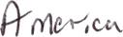
II. Sir Thomas, Bt. John, Elizabeth,
1702 Lyonel 1737
Alice Hopkins,1729 Rich. Beke
III.SirTho. Bt. 1749 Rt Hun. Sir Wm. 1754
Eliz. Sandy:, 1728 Anne Good I Margaret
win, 1729 Mdmoth
Thomas, I V. SirVi in. Bt. 1799 Anne
¹⁷⁴° Lady Eliz. HarCourt Geo. L.
Vernon
V. Sir Wil.am, VI. Rev. Sir Geo. -
Bart. 1801 Lee, Bart. d. y.
Mary,
1749
Frances
Jane, 1734
R.Wink- I Captain John Pad-
worth Nashack more
Sarah, 1693 Col. John Lee, 1760 Rt. Hon. Sir Geo.
— Hardy, I M. ¹⁷⁵⁸
1720 I Browne Judith Morice, 1743
Thomas Lee, of
Hampton Court
1 /0; •
William, 1772
Ph.Dyke,1799
Willia4 Lee
Anionic
d. S. P.
Lours,
Sophia y
Philadelphia Harriet, 1795
J. Fiott,Eaq.
1797
Digitized by _30081e

be 1\3 s-r2AcT

ax\⁻rALOc

i2kci-kic6,20 ⁻Tok.kr,1 (.5T C_LA 0 if•-r-Jrz +NI

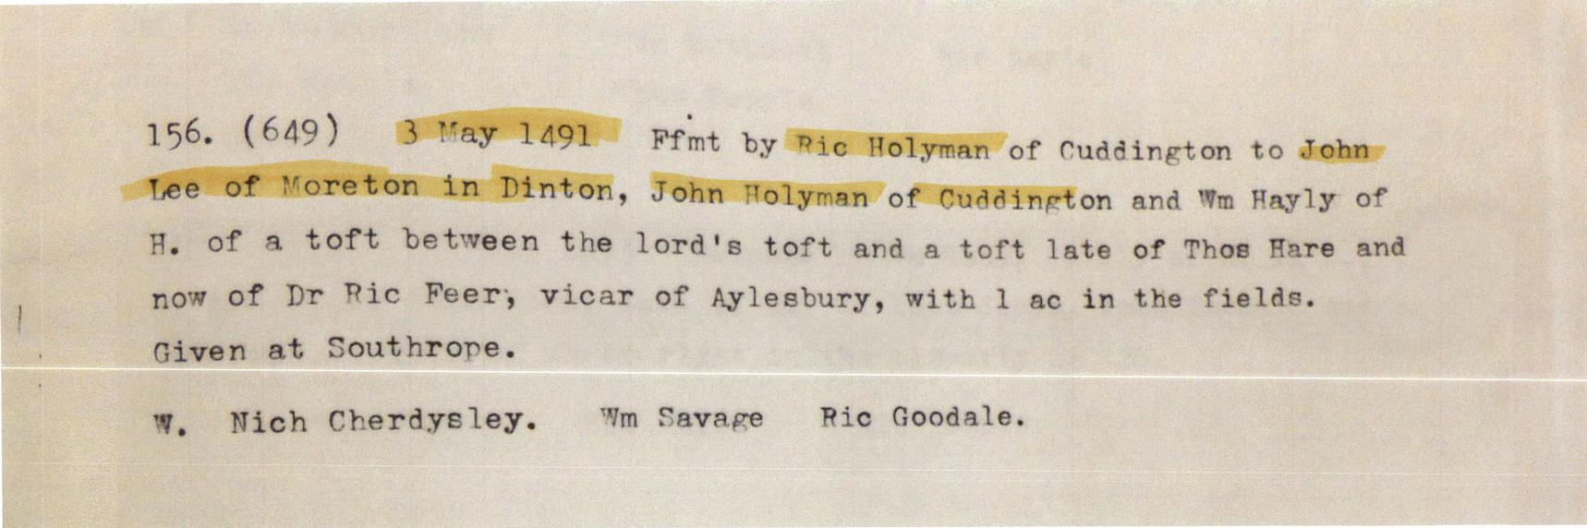

fee tail. all hi_{s} lands etc in tForeton or elsOhere to hold in
%_,utverhou_{s} of roretor to( oh_{r}
Titn: John. Tiee, Wm gurney,
John Py ot, Thos Pyrot
^{-,}g14^{.-}.1vAbroT60.442444e400,40#4
^{.4}1*" 160d
C .83 26 Mar 1905 Ffmt by richard Culverhowse of toretor. to
Richard Barnard, William Barnard, John Folytnan, Rnd John Penett of
a messuage in V. with 26 ac of land and pasture belonging to it.
To hold according to indres between T.C. and Richard Iliinett
Haddenham clated 20 'Mar 1508.
'litre: 'Villiam Famrden of ,a,rtwell, Thos Gurney of it.rstone, Richard
Venrour of Stone.
nru 7
•

